What is Anti Bribery Management System?

Bribery is one of the most destructive and complex problems of our times, and despite national and international efforts to combat it, it remains widespread. The World Bank estimates that over USD 1 trillion is paid in bribes each year , with disastrous impacts such as eroding political stability, increasing the cost of business and contributing to poverty. On a global level, it is a significant barrier to international trade, while within an organization it has a highly negative impact on employee morale. Many governments have taken measures to address bribery through national laws as well as international agreements such as the United Nations Convention against Corruption, but more can be done. Institutional change and an anti-bribery culture within organizations can contribute significantly to the fight against bribery and complement national and international measures.





ABMS

An anti-bribery management system is designed to instil an anti-bribery culture within an organization and implement appropriate controls, which will in turn increase the chance of detecting bribery and reduce its incidence in the first place. ISO 37001, Anti-bribery management systems – Requirements with guidance for use, gives the requirements and guidance for establishing, implementing, maintaining and improving an anti-bribery management system. The system can be independent of, or integrated into, an overall management system.

Where & how can Anti Bribery Management System be applied?

For **Anti Bribery Management System** (**ABMS** ), be applied to any organization, irrespective of size or industry sector. ABMS principle approach has following basic principles & strategies in place:

|  |  |
| --- | --- |
| Principles – QMS Principles may be considered to maintain  C, I & A of Information | Strategies |
| * Understanding Scope & Context to   See the source image   * Source of Bribery Understanding * Management Commitment for   ABMS   * Risk Assessment   – all Interested Parties   * Prevention & Detection of ABMS   Incident   * Comprehensive Approach * Regular review & Update of ABMS | * Focus on Source of Bribery in the Scope & Context of products & services * Identify VULNERABILITIES of Humans attracting Bribery   (Average Risk Appetite of Human Population – life style)   * Define Risk Assessment to identify Risk Impact of each Vulnerability of Bribery * Perform Risk Evaluation (Impact Level) on current controls and after new controls of bribery * Ensure that approval process by different basis to be strengthened (with criteria) which is one of the best method – easy to implement – where ever More or Strong Vulnerabilities |

What can make Anti Bribery Management System journey successful?

To implement & get maximum benefited from ABMS , there has to be ***baseline mindset principles***, in which every member of the organization (including Top Management) should believe in:

|  |  |
| --- | --- |
| Mind Set for ABMS | Benefits of ABMS |
| * Clear understanding the importance of antibribery and its impacts on businesses and society; * Open mind to adopt culture for new understanding & learning concepts, technology and its vulnerabilities of the bribery opportunities, in more precise manner; * Complete Transparency in understanding, implementing changes, if need be, at appropriate time for control of bribery opportunities; * **Always believe that, what we know today is not enough and not the end**; * Always believe in and practice team work, commitment to improve and believe in that bribery can be controlled; * **Any System to be in such a manner that people depend on System, & not the other way round**”; * Ask self-question all the time - “Am I interpreting the requirements of ABMS Standard in correct manner?; * Importance has to be given to documentation with Criteria inbuilt into it for internal transparency & believe in building up Process **KEDB (Known Error Data Base)** – and update in disciplined manner and ensure that this is accessible to every one. | * Clarity to Organization Governance to Secure Information in a better Systematic and Consistent manner; * New Risk Based mechanism shall open your minds in understanding the importance of Information, compared to time before, for future sustainability of the business; * Achieve greater consistency in the activities involved in providing security controls more effectively; * Gives opportunity to understand the limitations of security controls in the form of Residual Risks; * Increase efficiency by improving use of information in more legitimate manner. * Improve people competency in systematic manner & aim & enhance for better Information Value; * Market your business more effectively; * Exploit new market sectors and territories; * Manage growth more effectively by making it easier to integrate new employees; * Constantly improve your process compliance to regulations, on periodical basis as technology comes first and then the laws. |

What is Annexure L?

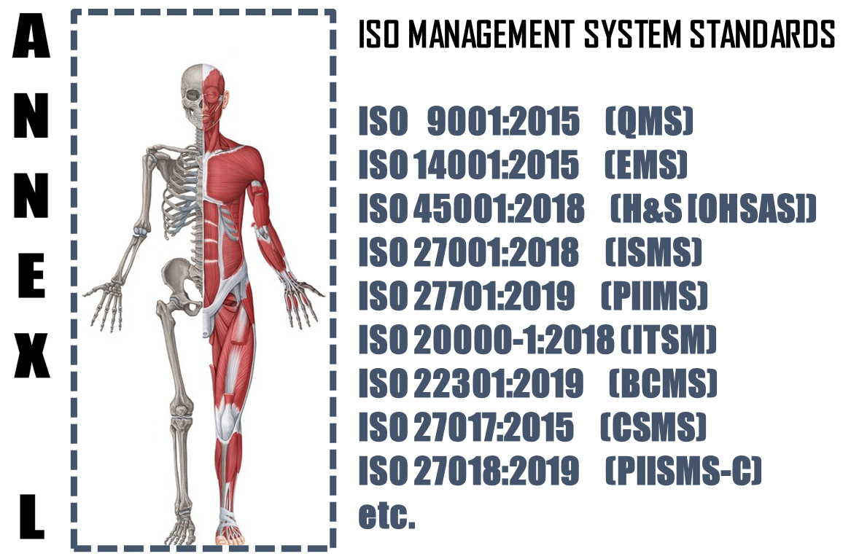

The **Annex L** (now renamed as Annex L in the 2019th edition from Annex SL) is a section of the ISO/IEC Directives part 1 that prescribes how ISO Management System Standard (MSS) standards should be written. The aim of Annex L is to enhance the consistency and alignment of MSS by providing a unifying and agreed-upon high level structure, identical core text and common terms and core definitions. The aim being that all ISO Type A MSS (and B where appropriate) are aligned and the compatibility of these standards is enhanced.

So in short we can say that Annex L is the Skeleton of ISO Management Systems and all standards are now aligned as per Annex L and all the common elements terms and definitions have also been standardized. This has been done to bring in Standard in the Structure, which was not the case in the past, though the intention was the same. So we can say, out of Intent and Content of MS, Content has undergone a change, in the form of Anne L.

What to do in Implementing Anti Bribery Management System?

Based on the Scope and Context, following activities have to be performed in logical sequence. These guidelines given below are only basic milestones and a lot of activities may have to be streamlined as per the standard, based on Scope & Context.

|  |  |  |  |  |
| --- | --- | --- | --- | --- |
| **Step #** | **Requirement of ABMS** | **What needs to be done (**C, I & A Separately) | **In what way IRCBO can contribute** | **Tools Recommended** |
| 1 | Defining & Documentation | * Defining & Documenting Scope (Technical [Product/Services] and Territorial Scope (# Locations) where the MS is needed. The Org. Management decides the specific scope in line with Applicable regulations * Defining the External & Interested Parties, their business relationship with Org. (in relevance to scope), Identification of critical processes, Information & Information classification); * All relevant policies and procedures for delivery of products and services, as per scope & context - these procedures or process documents for each interested party activities shall include acceptance criteria as well – including Design of Product/Service Processes; | IRCBO’s Qualified & Experienced consultants can help you in designing, defining, Implementing, monitoring and Improving the MS.  Note: Our contracts can also be associated after Certification for Maintenance of Management System through our digitized tool contributions – aim is to make any MS a plug and play for most effective Controls & Complying (including Legal Compliances) | IRCBO Tool Kit which includes all solutions for Implementation and backed up by IRCBO Designed Software in cloud for :   * Online training   (including  Induction for new employees, awareness & unlimited Internal Auditor Training & Qualification   * Online Internal Auditing Software – this also includes tracking of corrective actions |
| 2 | Implementation | * Implementing all policies and procedures as per ABMS defined system; * Assigning and plying Responsibilities and Authorities in more transparent manner; * Participating in Risk Mechanism and approving Residual Risk and Incident investigations – for C, I & A Separately * Focusing on Increasing Competency, * Maintaining good discipline in demonstrating Leadership and aiming for improvements through Management Review platforms; |
| 3 | Periodical Review | * Monitoring, measuring and performing Analysis to ensure * Considering Internal Audit Findings seriously for Timely Corrective Actions in effective manner and take decisions to improve in Management Reviews |
| 4 | Continual Improvement | Implement all actions of Management Review and aim for Continual Improvement – remember Improvement & Continual Improvement are different Concepts |